Javascript Notes for self use

For - in loop : To loop through an array / object to extract its values.

Eg:

let obj = {

    harry : 90,

    shubh: 44,

  smayan: 48,

    shriayns: 45

  }

  for(let a in obj)

    {

      console.log("The marks of " + a+" are " + obj[a])

    }

Output:

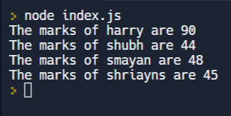

For - of Loop: To get the values of the array/obj/string one by one

Eg:

for(let b of "Smayan")

  {

    console.log(b)

  }

Output:



Template Literals:

When you need to add a string value inside another string

Ex:

let b1 = "smayan"

let b2 = "shriyans"

let c = `${b1} is the brother of ${b2}`

console.log(c)

Here the ${b1} is inserting the value of string b1 inside the string c.

This is called **String Interpolation.**

Slice:

To remove a certain part of a given string

Ex:

let b2 = "namehere"

let c = b2.slice(2,4);

Let d = b2.slice(3);

console.log©

Arrays:

Converting arrays into string :

let num = [5,23,234,5]

let b = num.toString()

console.log(b, typeof b)

let d = num.join("_")

console.log(d, typeof d)

let e =num.pop()

console.log(num,e) // removed the last element of an arary an returns the popped element

let f =num.push(45); // returns the new array length

console.log(num,f)

let g = num.shift() // removes the first element of an array

console.log(num, g)

let h = num.unshift(10) // as new element to an array an returns the new array length

console.log(num, h)

Output:

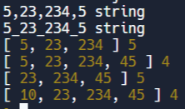

Delete operator:

let num = [1,2,3,4,5,6]

delete num[0] // the delete function doesn't change the array length

console.log(num, num.length)

Output:



Sort function:

let num = [1,252,4523,49244,255,75756,10000000000]

num.sort() // sorts numbers by only comparing the initial number

console.log(num, num.length)

Output:

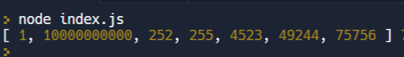

To sort in ascending order:

let compare =(a,b) =>

  {

    return b-a;

  }

let num = [1,252,4523,49244,255,75756,10000000000]

num.sort() // sorts numbers by only comparing the initial number

console.log(num, num.length)

Output:

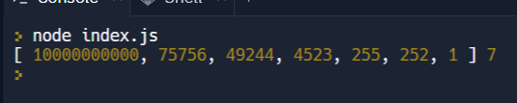

Slice: Add new items to an array

let num = [551, 22, 3, 14, 5, 6, 7, 8, 229]

let deletedValues = num.splice(2, 4, 1021, 1022, 1023, 1024, 1025)

console.log(num)

console.log(deletedValues)

Output:

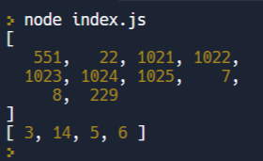

Slice:

Slices out a piece from a n array to form a new array

let num = [551, 22, 3, 14, 5, 6, 7, 8, 229]

let  newNum = num.slice(3, 5)

let newnew = num.slice(3)

console.log(newNum)

console.log(newnew)

Output:

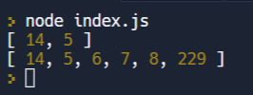

Map Function:

let arr=[4,3,3]

let a =arr.map((value,index,array)=>{  //differnce between forEach an map is that map makes a new usable Array

  console.log(value,index,array)

  return value +1

})

console.log(a)

Output:

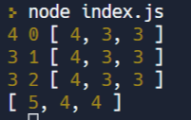

Array Filter Func: Filters an array with values that passe a test, creates a new array.

Does not change the original Array.

let arr=[4,3,3]

let a = arr.filter((a)=>{

 return a<10

})

console.log(a)

Output:

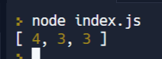

Array Reduce Method:

let arr=[4,3,3]

let a= arr.reduce((h1,h2)=>{

  return h1+h2

})

console.log(a) //works in a way that it adds all the elements of anarray one by one

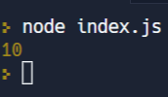

Factorial calculator with reduce method:

let arr=[1,2,3,4,5]

let n= arr.reduce((x1,x2)=>{

  return x1*x2;

})

console.log(n)

Output:

120.

Different Console Functions:

1. console.log(): output
2. Console.error() : shows errors
3. Console.assert() : only true statement will be asserted, otherwise the assertion will fail
4. Console.clear() : clear the console
5. Console.table() : to make table from given assorted data
6. Console.warn() : shows a statement warning the user about a certain part of the code
7. Console.info() : falls under info category in the console

To see all type : console.table(console) in the browser console.

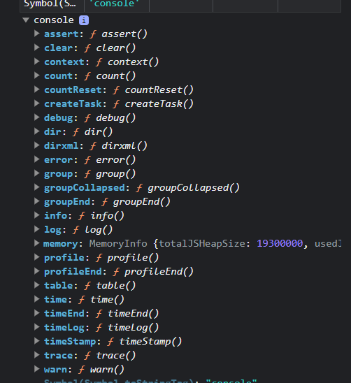

Console.time is a very useful func which can be used to measure the time required for a process in milliseconds.

Aller() : A function which shows an alert saying a statement which you add to it.\

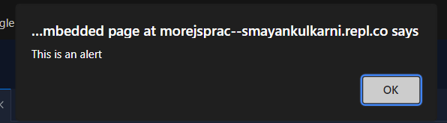

Prompt() and document.write() are func used to write something u entered from promt into the page.

{dont forget to use number..parseInt() tpo convert into int}

# Window Object, BOM and DOM

Window object represents browser window and provides methods to control it. It is a global object.

Document Object module (DOM)

DOM represents page content as HTML

Browser Object Module (BOM)

Represents additional objects provide by the browser (host environment) for working with everything except the document.\